A22 Ex01 AssafGorovici 313547358 OriBlanka 208994764

Feature 1: My Events

Our First Feature is first accessed on the FormMain. Under the Login Button there are 3 tabs, the second tab called “My Events” is where this feature is located. After clicking the “My Events” tab, the user will notice a comboBox, a “Fetch Events” button, and a currently empty dataGrid. With this feature the User will be able to retrieve all the events from the User’s facebook profile and display each event’s relevant information in in the dataGrid. What is unique to our feature is that we will give the user three options to filter the User’s events and display the filtered events in the dataGrid. The User has to chose one option in the comboBox and then click “Fetch Events” to display the filtered results. One option is to display all events, second option is to display only online events (for example webinars), and the third option is to display not online events (at physical location). Each option will be displayed in the dataGrid.

Feature location in code:

FormMain: buttonFetchEvents_Click()

AppLogic: FetchEvents()

Feature 2: Mutual Liked Pages

Our Second Feature is also first accessed on the FormMain. Under the Login Button there are 3 tabs, the third tab called “Mutual Liked Pages” is where this feature is located. After clicking the “Mutual Liked Pages” tab, the user will notice a button and an empty listBox. With this feature the User will be able to retrieve a list of all of their friends that have liked the same pages as them. All they need to do is click on the button called “Click here to see your friends that like similar pages” and the list of the friends will be displayed in the listBox.

Feature location in code:

FormMain:

AppLogic:

Use Case Diagram:

Sequence Diagram: Feature 1: My Events

Sequence Diagram: Feature 2: Mutual Liked Pages

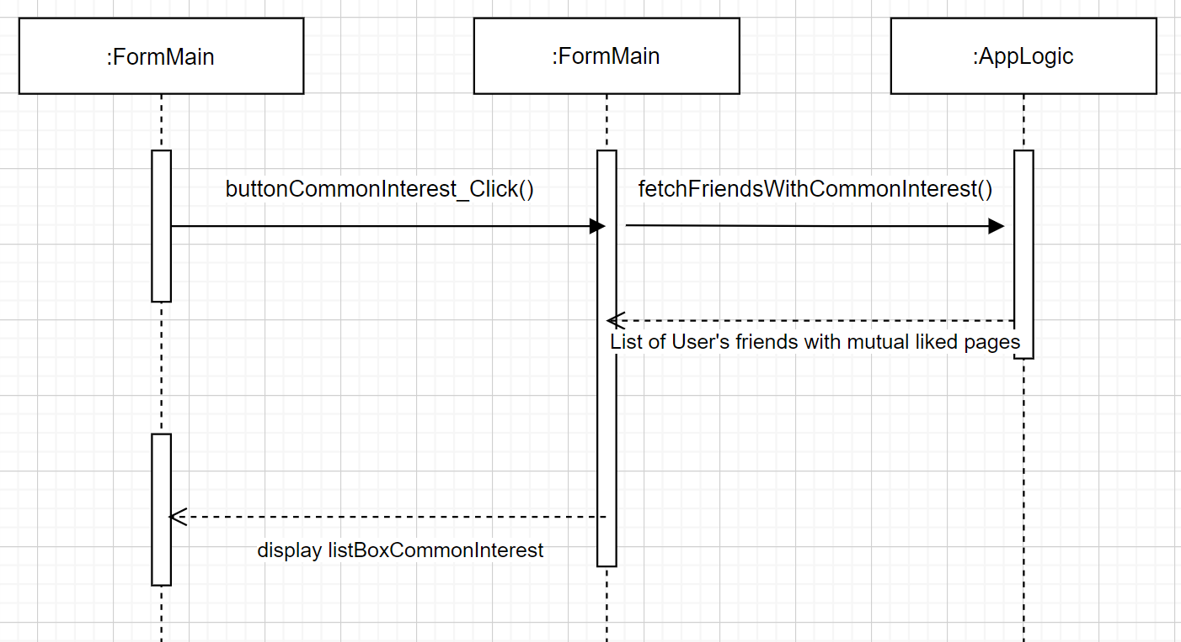

Class Diagram:

